1. Let’s create AWS Account.
2. A screenshot of a sign up form

   Description automatically generated
3. 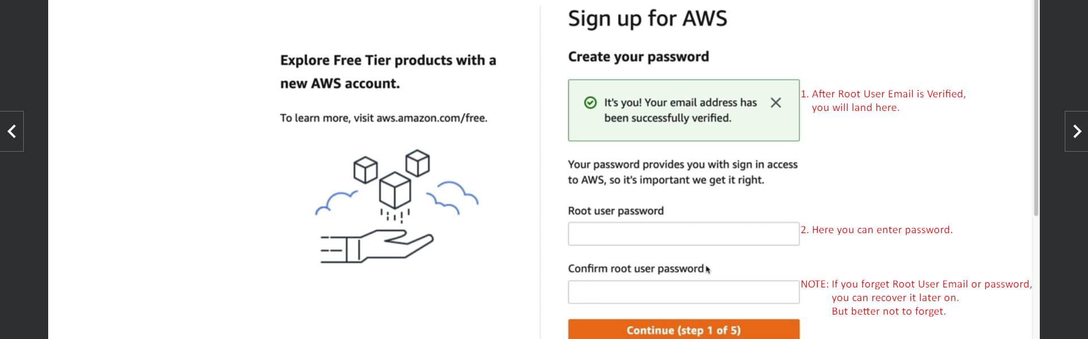
4. Personal Account Detail:  
   A screenshot of a computer

   Description automatically generated
5. A screenshot of a sign up form

   Description automatically generated
6. A screenshot of a computer

   Description automatically generated
7. A screenshot of a computer program

   Description automatically generated
8. A screen shot of a computer

   Description automatically generated
9. A screenshot of a computer

   Description automatically generated